R KALAI AMUDHAN(192511292)

JIRA EXPERIMENTS
EX01- KAMBAN BOARD
AIM:
To Create a Kanban Board to Visualize the Tasks.
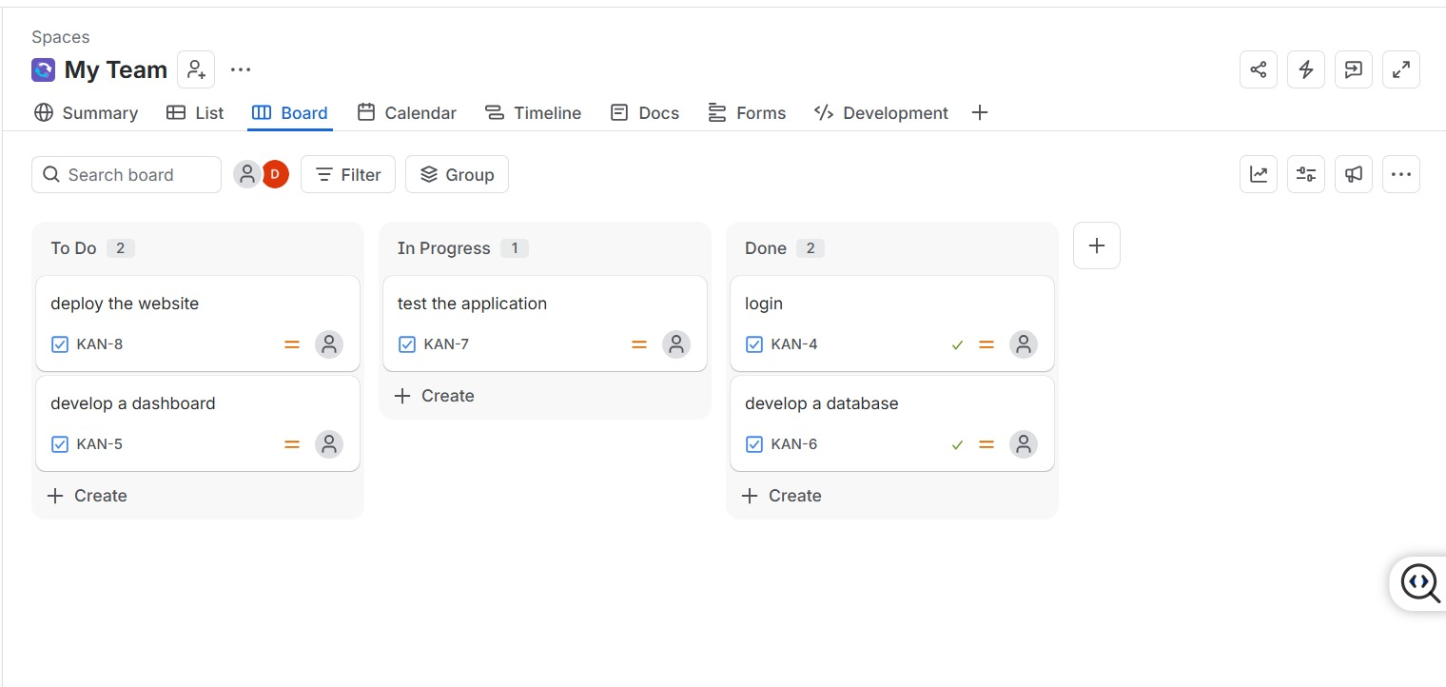
EX09- LIBRARY MANAGEMENT USING MOSCOW
Aim
To create a Scrum project in Jira, add backlog items, prioritize them, create a sprint, start the sprint, and track progress using the sprint board.
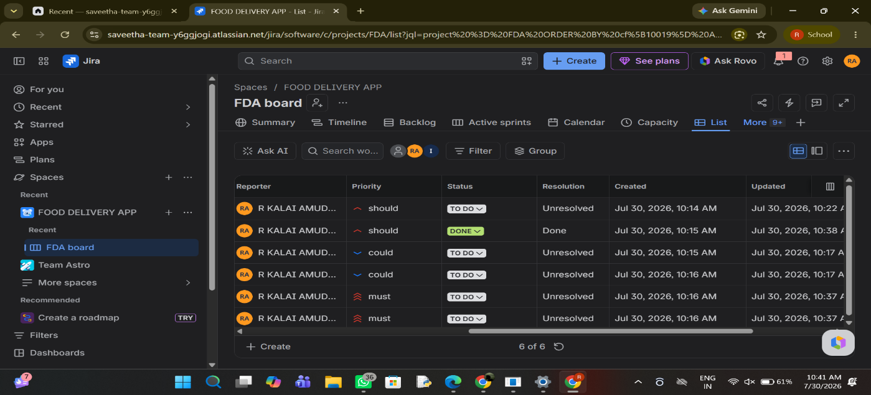
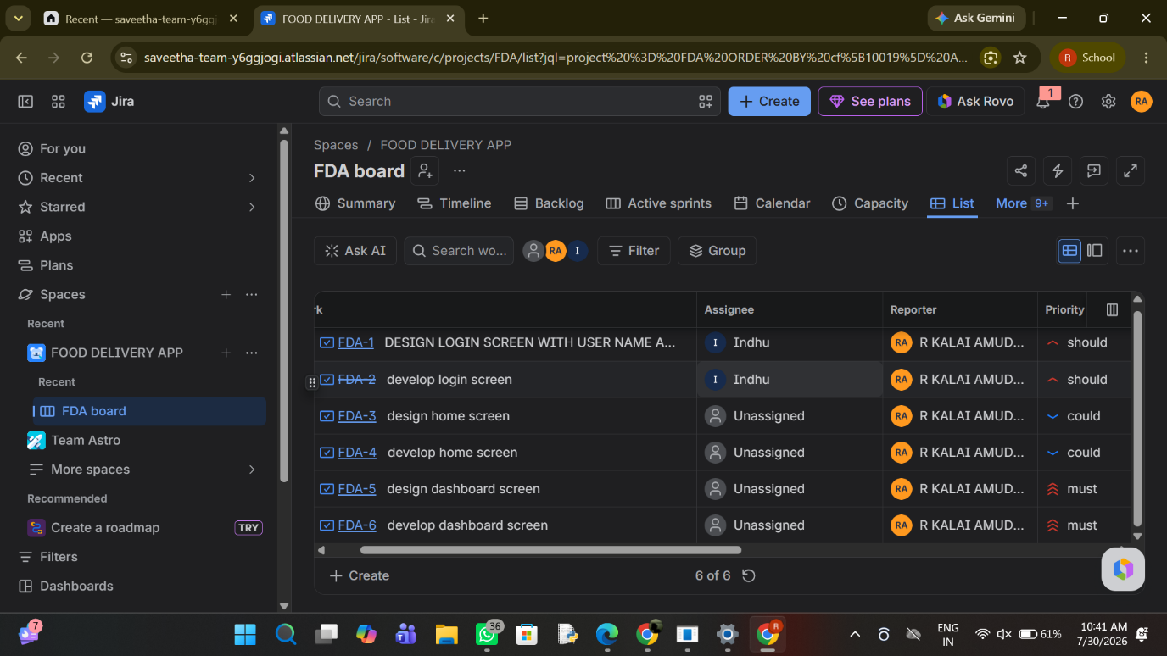

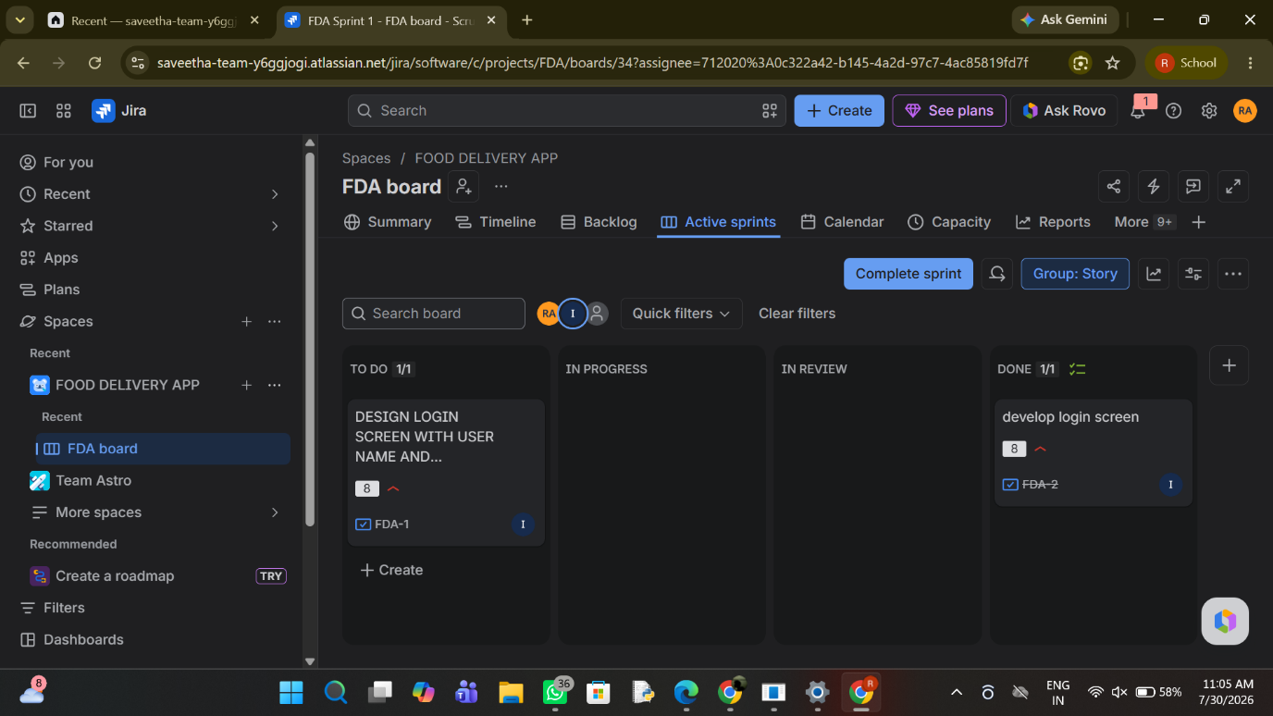

Result
Thus, a Scrum project was successfully created in Jira with backlog prioritization, sprint planning, sprint execution, and sprint completion.
EX11 - LIBRARY MANAGEMENT WITH CONFLUENCE
AIM:
To Link Jira tasks with Confluence to streamline task tracking and progress monitoring for the Library Management System development.

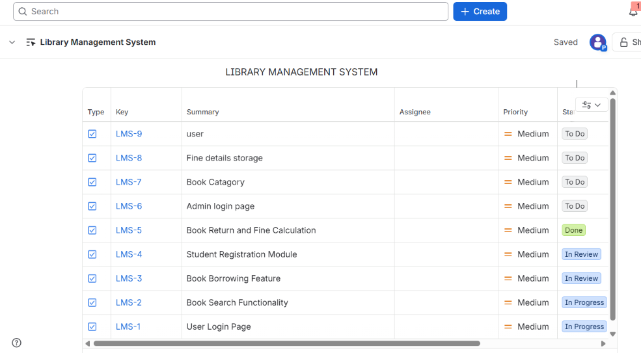
EX12- Task Management System
AIM:
To designing a Task Management System for a small team.
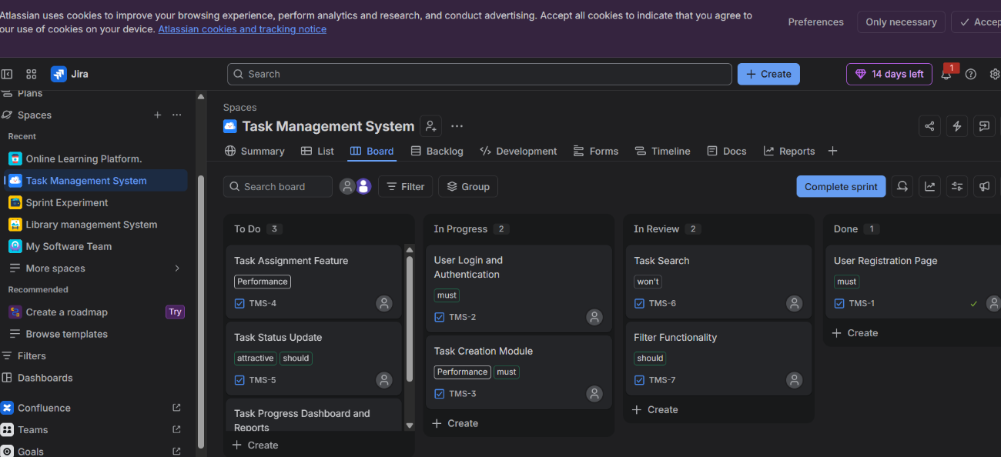

EX13- ONLINE LEARNING PLATFORM.
AIM:
To develope an Online Learning Platform.
FLOWCHART:

